I was originally going to do all the columns, but there is a lot of data. It is overwhelming to analyze all of it at once.
X: columns 1 & 2-7
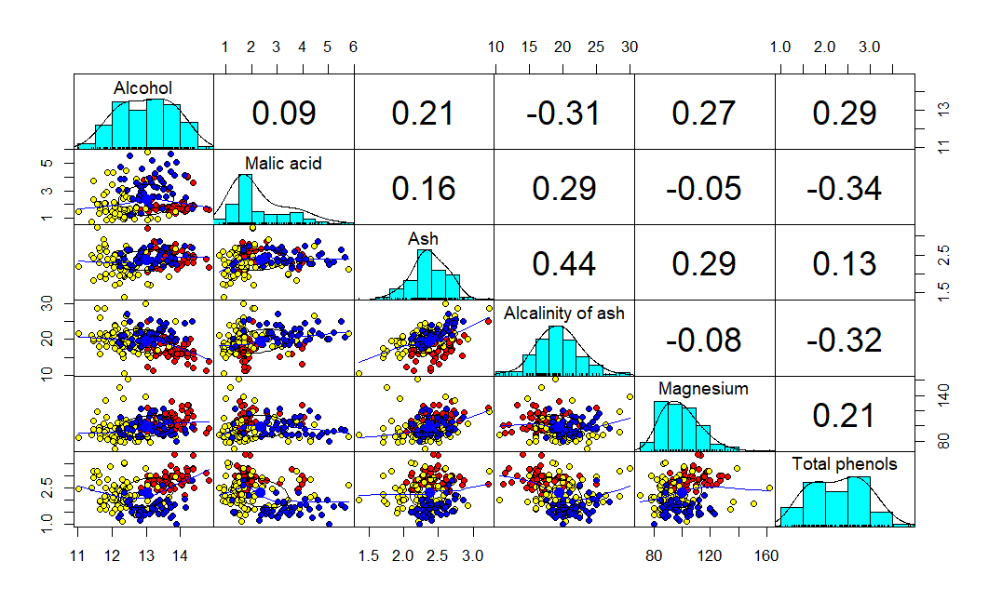
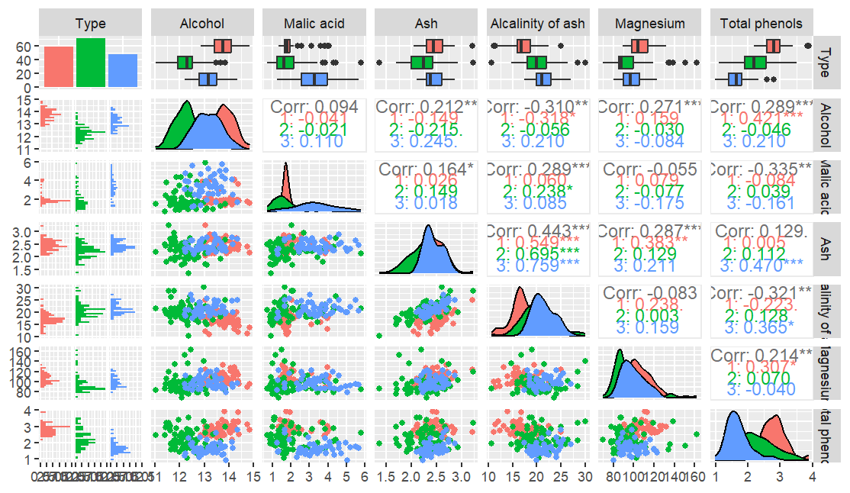
Y: column 1 & 8-13
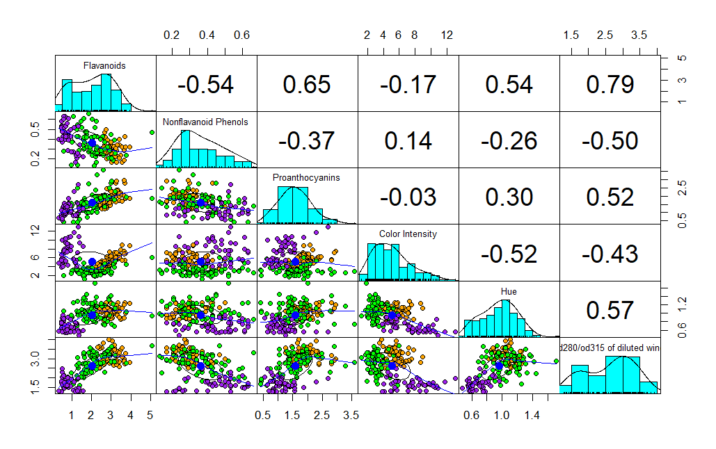
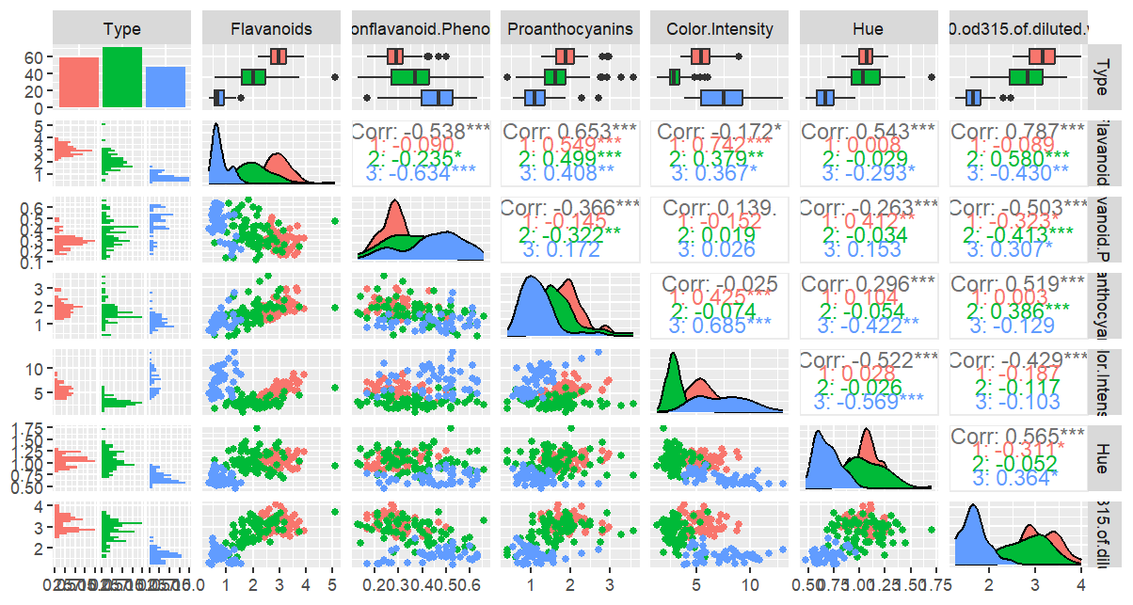

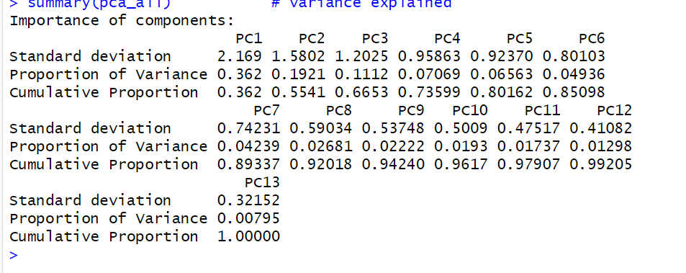
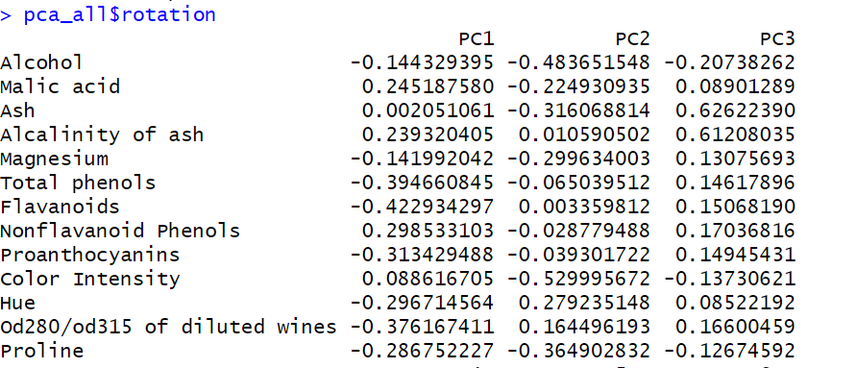
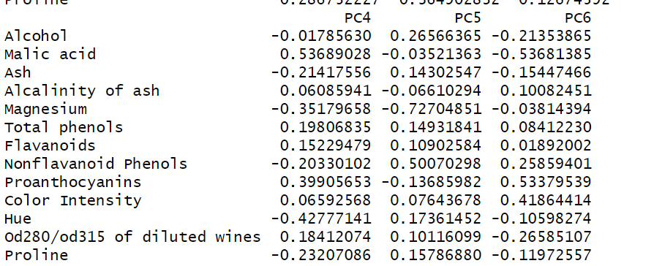
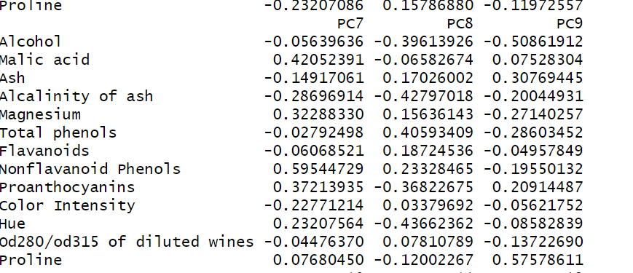
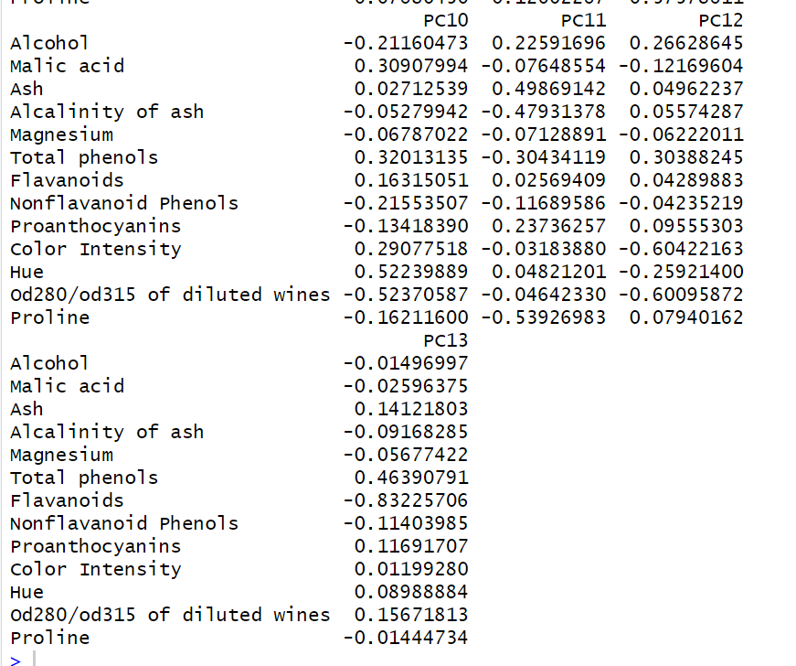

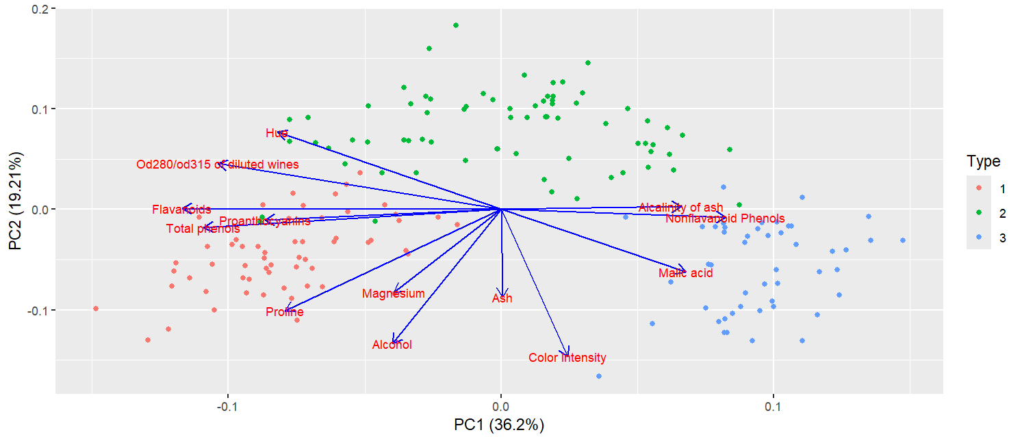
With PCA 1, the variables that contribute most are Alcalinity of ash, Nonflavored Phenols, Flavonoids, Proanthocyanins, and Total phenols.
With PCA 2, the variables that contribute the most are Ash, and Color Intensity.
We can tell because those variables are most aligned with the respective axes.

kNN
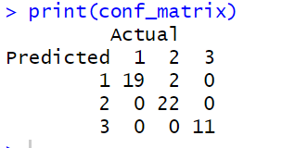
Accuracy: 96.3 %

DECISION TREE
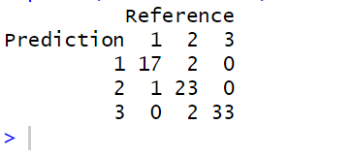
Accuracy
0.9358974

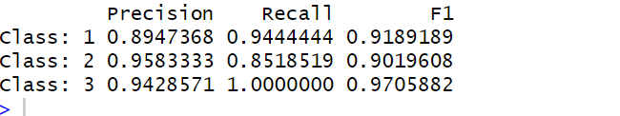

Comparing the two models

